LAB NO 1
AMNA SALEEM HAYAT
PRACTICE TASKS

SUBMITTED TO : SIR MOEEZ JAVED

PRACTICE TASK 1
STEP 1: DATA COLLECTION
cat > auth.log <<'EOF'
2025-09-02 09:00:01 host sshd[1234]: Failed password for invalid user admin from 192.168.1.100 port
53718
2025-09-02 09:01:05 host sshd[1234]: Failed password for invalid user admin from 192.168.1.100 port
53719
2025-09-02 09:02:10 host sshd[1234]: Accepted password for user alice from 192.168.1.100 port 53720
2025-09-02 09:03:11 host sshd[2234]: Failed password for invalid user test from 192.168.1.200 port 532
11
EOF
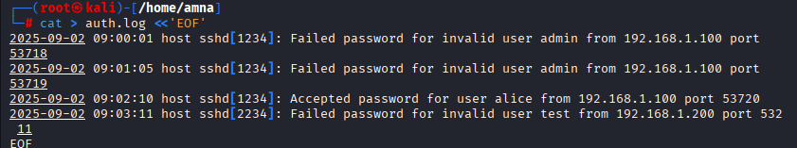
STEP 2: Information Extraction with Python
cat > walkthrough.py <<'PY'
#!/usr/bin/env python3
import re
from collections import defaultdict
import sys
import os

logfile = "auth.log"

# Single-line raw string for regex (no split across lines).
# This pattern matches lines with a timestamp (YYYY-MM-DD HH:MM:SS) and either
# "Failed password" / "Accepted password" or "failed"/"success" forms, then extracts IP.
pattern = re.compile(
r"""
(?P<ts>\d{4}-\d{2}-\d{2}\s+\d{2}:\d{2}:\d{2}) # timestamp
.*? # any text in between
(?:
Failed\ password|Accept(?:ed)?\ password| # common ssh forms
failed|success # your earlier simple forms
)
.*? # any text
(?P<ip>\d{1,3}(?:\.\d{1,3}){3}) # IPv4 address
""",
re.VERBOSE | re.IGNORECASE
)

if not os.path.isfile(logfile):
print(f"ERROR: log file not found: {logfile}", file=sys.stderr)
sys.exit(1)

attempts = defaultdict(list)

with open(logfile, "r", encoding="utf-8", errors="ignore") as f:
for line in f:
m = pattern.search(line)
if m:
ip = m.group("ip")
# determine status by checking words in the matched line
low = line.lower()
if "failed password" in low or "failed" in low:
status = "failed"
elif "accepted password" in low or "success" in low:
status = "success"
else:
status = "unknown"
attempts[ip].append(status)

for ip, logs in attempts.items():
fails = sum(1 for s in logs if s == "failed")
succ = sum(1 for s in logs if s == "success")
print(f"IP: {ip}, Failures: {fails}, Success: {succ}")
PY
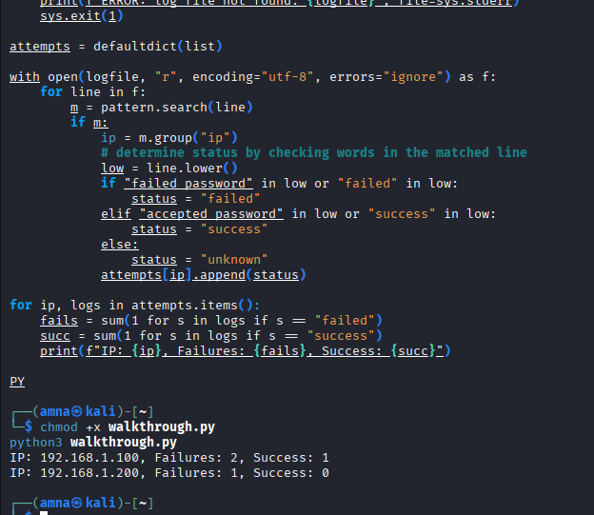
STEP 3: KNOWLEDGE APPLICATION
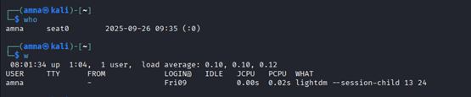
STEP 4: WISDOM
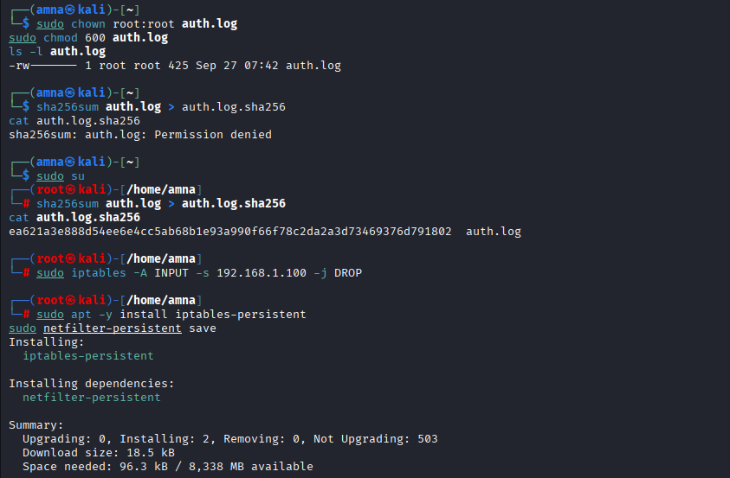
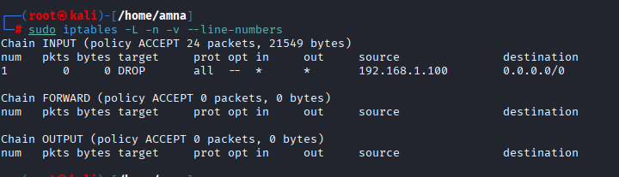
PRACTICE TASK 2
cat > temp_sensor.py <<'PY'
#!/usr/bin/env python3
import time
import random
from datetime import datetime

LOGFILE = 'temp.log'
THRESHOLD = 30.0

with open(LOGFILE, 'a') as f:
for i in range(20):
temp = round(random.uniform(20.0, 35.0), 1)
ts = datetime.now().strftime('%Y-%m-%d %H:%M:%S')
line = f"{ts} Temperature: {temp} C\n"
f.write(line)
f.flush()
print(line.strip())
if temp > THRESHOLD:
alert = f"{ts} ALERT: temperature {temp}C exceeds threshold {THRESHOLD}C\n"
f.write(alert)
f.flush()
print(alert.strip())
time.sleep(1)
PY
